Ebony Postell

Week 5 Matplotlib 7/6/19

Observations

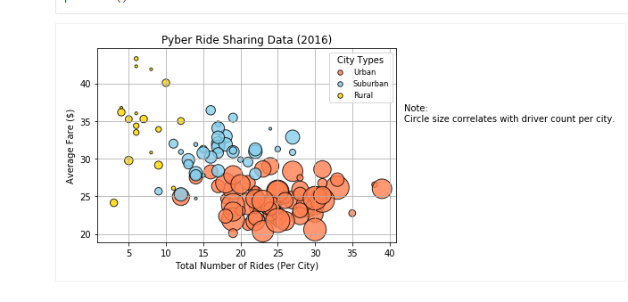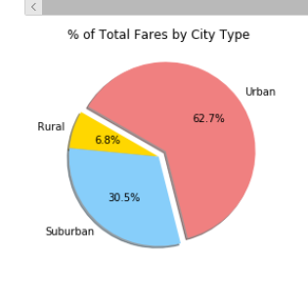 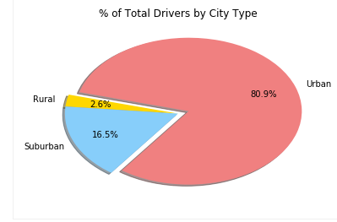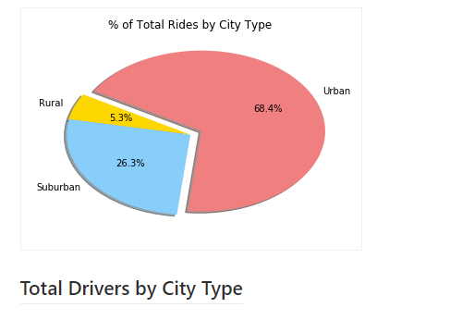

My observation is that the urban community shows a higher percentage in it all the categories. The number of rides and average fare are closely averaged. The rural and suburban communities are both low percental. The Urban communities are definitely going to have higher fares high due to the higher demand.